|  |
| --- |
|  |

Software Requirement Specification

Project: SimpleTorrent

Revision 1.0

|  |  |  |
| --- | --- | --- |
|  |  | Julio, 2016 |

The document file

|  |  |  |  |
| --- | --- | --- | --- |
| **Data** | **Revision** | **Author** | **Verified dep. quality.** |
| 30/07/2016 | 1.0 | Raúl Eduardo Durán Carrasco |  |

Content

The document file 2

Content 2

1 Introduction 4

1.1 Purpose 4

1.2 Scope 4

1.3 Personnel involved 4

1.4 Definitions, acronyms y abbreviations 4

1.5 References 4

1.6 Overview 4

2 General Description 5

2.1 Product’s perspective 5

2.2 Product’s functionality 5

2.3 Users’ features 5

2.4 Restrictions 6

2.5 Assumptions y dependencies 6

3 Specific requirements 6

3.1 Functional requirements 6

3.2 Non-Functional requirements 9

3.3 Common interfaces’ requirements 9

3.3.1 User interfaces 9

3.3.2 Hardware interfaces 9

3.3.3 Software interfaces 9

3.4 Function requirement 10

3.4.1 Functional requirement 1 10

3.4.2 Functional requirement 2 10

3.4.3 Functional requirement 3 10

3.4.4 Functional requirement 4 10

3.4.5 Functional requirement 5 10

3.4.6 Functional requirement 6 10

3.4.7 Functional requirement 7 11

3.4.8 Functional requirement 8 11

3.4.9 Functional requirement 9 11

3.4.10 Functional requirement 10 11

3.4.11 Functional requirement 11 11

3.4.12 Functional requirement 12 11

3.4.13 Functional requirement 13 11

3.5 Non-Functional Requirements 12

3.5.1 System interface 12

# Introduction

This document is a Software requirements specification (SRS) for SimpleTorrent software. This specification has been structured on the basis of the guidelines given by the standard IEEE recommended practice for Software requirements specifications of ANSI/IEEE 830, 1998.

## Purpose

This document is intended to define the functional and non-functional specifications for the development of a standalone information system that will allow the downloading of files via the BitTorrent protocol. This will be used by any user.

## Scope

This specification is intended for the user of the system, to continue with the development of free software and to deepen in the automation of tasks, which is main objective to improve the skill of the developer and the quality of the delivered software.

## Personnel involved

|  |  |
| --- | --- |
| Name | Raúl Eduardo Durán Carrasco |
| Role | Analyst, designer and programmer |
| Professional Category | UT-Computer Science |
| Responsibilities | Analysis of information, design and programming of the SIS-I |
| Contact information | raul.d.carrasco@outlook.com |

## Definitions, acronyms y abbreviations

|  |  |
| --- | --- |
| ***Name*** | ***Description*** |
| **User** | Human who will use the computer system. |
| **SIS-I** | Standalone download information system via the BitTorrent protocol. |
| **SRS** | Software requirements specification |
| **FR** | Functional requirement |
| **NFR** | Non-functional requirements |
| **Torrent** | A file that stores metadata used by a BitTorrent client. A Torrent is information about a target file, although it does not contain information about the contents of the file. |
| **BitTorrent** | It’s a protocol designed for point to point (peer-to-peer) file-sharing on the Internet. |

## References

|  |  |
| --- | --- |
| **Document’s Title** | **Reference** |
| Standard IEEE 830 - 1998 | IEEE |

## Overview

This document consists of three sections. In the first section is an introduction to the same, and provides an overview of the specification of the system resources.

In the second section of the document is a general description of the system, in order to learn main functions, it should perform, the associated data and factors, restrictions, assumptions and dependencies that affect development, without going into excessive detail.

Finally, the third section of the document is one which defines in detail the requirements that must satisfy the system.

# General Description

## Product’s perspective

The SIS-I system is a product designed to work in desktop environments, allowing viewing in any desktop of any operating system, will also come supplied with a simple configuration panel that allows the user to control bandwidth and the language of the SIS-I.

## Product’s functionality

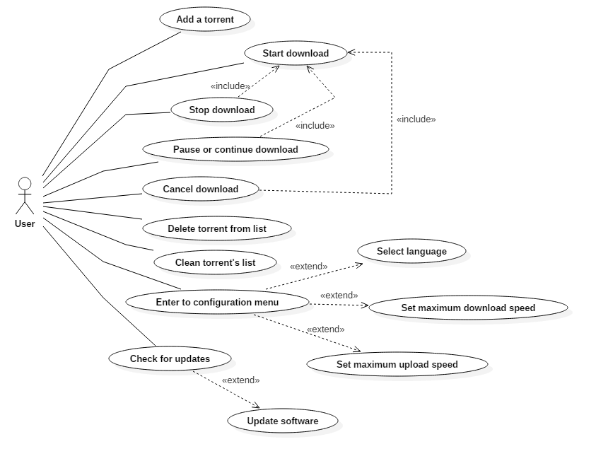

Diagram Nº 1 - Interaction User-Sw

## Users’ features

|  |  |
| --- | --- |
| User type | User |
| Activities | Download, upload and download and upload control of files via the BitTorrent protocol. |

## Restrictions

* Interface to be used on desktop.
* Languages and technologies to be used: Java, SQLite.
* The system should have a minimalist design.
* The computer where the SIS-I will be implemented should own and run optimally the Java virtual machine.

## Assumptions y dependencies

* It’s assumed that the requirements described here are stable.
* The computer on which the system will be implemented must meet the above requirements to ensure a correct execution of the system.

# Specific requirements

## Functional requirements

|  |  |
| --- | --- |
| **Requirement’s ID:** | FR01 |
| **Requirement’s name:** | Add a torrent |
| **Features:** | The user can add new Torrent files to the application for download of the target files. He shall provide a valid path where files will be stored before he begins the download. |
| **Requirement’s description:** | Allows the addition of Torrent files to download files. |
| **Non-Functional Requirements:** | * NFR01 |
| **Requirement’s priority:**  High | |

|  |  |
| --- | --- |
| **Requirement’s ID:** | FR02 |
| **Requirement’s name:** | Start download |
| **Features:** | The user can start a download of a selected torrent. If the download were stopped before, then it continues. To select a torrent, the user must click it on the list showed in the main frame of the SIS-I. |
| **Requirement’s description:** | Allows to start an unstarted download of a torrent file. |
| **Non-Functional Requirements:** | * NFR01 |
| **Requirement’s priority:**  High | |

|  |  |
| --- | --- |
| **Requirement’s ID:** | FR03 |
| **Requirement’s name:** | Stop download |
| **Features:** | The user can stop a download that is already started. This means that the download doesn’t download more until the user indicates its start again. |
| **Requirement’s description:** | Allows to “freeze” the download of a torrent. |
| **Non-Functional Requirements:** | * NFR01 |
| **Requirement’s priority:**  High | |

|  |  |
| --- | --- |
| **Requirement’s ID:** | FR04 |
| **Requirement’s name:** | Pause or continue download |
| **Features:** | The user can pause or continue a download if that download is already started. The pause reduces the maximum download speed to 10Kbps. The continue returns the default maximum download speed and can only be perform if the download is already paused. To pause or continue a download, the user must select a torrent on the torrent’s list. |
| **Requirement’s description:** | Allows to reduce the maximum download speed of a download to 10Kbps and resume it to its normal speed. |
| **Non-Functional Requirements:** | * NFR01 |
| **Requirement’s priority:**  High | |

|  |  |
| --- | --- |
| **Requirement’s ID:** | FR05 |
| **Requirement’s name:** | Cancel download |
| **Features:** | The user can cancel a download. It means that the download is stopped, all the downloaded files are erased and its advance is reset. The SIS-I will ask for confirmation to the user before its performing. |
| **Requirement’s description:** | Allows to cancel a download and delete all its current advance. |
| **Non-Functional Requirements:** | * NFR01 |
| **Requirement’s priority:**  High | |

|  |  |
| --- | --- |
| **Requirement’s ID:** | FR06 |
| **Requirement’s name:** | Delete torrent from list |
| **Features:** | The user can delete a torrent from the torrent’s list in the main frame. The information about the torrent will not be available in the SIS-I anymore. This also delete the downloaded files and the current advance. |
| **Requirement’s description:** | Allows to delete a torrent from the torrent’s list. All its information will be deleted including the downloaded files of the torrent. |
| **Non-Functional Requirements:** | * NFR01 |
| **Requirement’s priority:**  High | |

|  |  |
| --- | --- |
| **Requirement’s ID:** | FR07 |
| **Requirement’s name:** | Clean torrent’s list |
| **Features:** | The user can delete all the canceled and unstarted torrents from the torrent’s list. The information about the torrents in the SIS-I will be deleted. |
| **Requirement’s description:** | Allows delete all the information of all canceled and unstarted torrents from the SIS-I. |
| **Non-Functional Requirements:** | * NFR01 |
| **Requirement’s priority:**  High | |

|  |  |
| --- | --- |
| **Requirement’s ID:** | FR08 |
| **Requirement’s name:** | Enter to configuration menu |
| **Features:** | The user can select the configuration menu’s option to visualized all the settings available. |
| **Requirement’s description:** | Allows to visualized a frame with the setting for the SIS-I |
| **Non-Functional Requirements:** | * NFR01 |
| **Requirement’s priority:**  High | |

|  |  |
| --- | --- |
| **Requirement’s ID:** | FR09 |
| **Requirement’s name:** | Select language |
| **Features:** | The user can select the language of the SIS-I. The languages available will be English and Spanish. |
| **Requirement’s description:** | Allows to set the language of the SIS-I. |
| **Non-Functional Requirements:** | * NFR01 |
| **Requirement’s priority:**  High | |

|  |  |
| --- | --- |
| **Requirement’s ID:** | FR10 |
| **Requirement’s name:** | Set maximum download speed |
| **Features:** | The user can set the maximum download speed for the downloads of all torrents. The maximum download speed must be an integer positive number greater than 0 (zero). If the user set 0 (zero), the maximum speed will not be limited. |
| **Requirement’s description:** | Allows to set the maximum download speed for the downloads of all torrents. |
| **Non-Functional Requirements:** | * NFR01 |
| **Requirement’s priority:**  High | |

|  |  |
| --- | --- |
| **Requirement’s ID:** | FR11 |
| **Requirement’s name:** | Set maximum upload speed |
| **Features:** | The user can set the maximum upload speed for the upload of all torrents. The maximum upload speed must be an integer positive number. If the user set 0 (zero), the uploads will not be performing. |
| **Requirement’s description:** | Allows to set the maximum upload speed for the uploads of all torrents. |
| **Non-Functional Requirements:** | * NFR01 |
| **Requirement’s priority:**  High | |

|  |  |
| --- | --- |
| **Requirement’s ID:** | FR12 |
| **Requirement’s name:** | Check for updates |
| **Features:** | The user can check for the SIS-I updates in the “about” frame. |
| **Requirement’s description:** | Allows to check for updates of the SIS-I. |
| **Non-Functional Requirements:** | * NFR01 |
| **Requirement’s priority:**  High | |

|  |  |
| --- | --- |
| **Requirement’s ID:** | FR13 |
| **Requirement’s name:** | Update software |
| **Features:** | The user can accept the update, downloading and installing the latest version of the SIS-I if the user’s SIS-I is older. |
| **Requirement’s description:** | Allows to update the SIS-I. |
| **Non-Functional Requirements:** | * NFR01 |
| **Requirement’s priority:**  High | |

## Non-Functional requirements

|  |  |
| --- | --- |
| **Requirement’s ID:** | NFR01 |
| **Requirement’s name:** | The system interface. |
| **Features:** | The system will present a simple and minimalist user interface. Simple means that all the options will be displayed in an easy access way and minimalist means that just the necessary options for a download/upload will be available. |
| **Requirement’s description:** | The user interface will be simple and minimalist. |
| **Requirement’s priority:**  High | |

## Common interfaces’ requirements

### User interfaces

The user interface will consist of a set of windows, buttons, lists, tables, and text fields. This must be built specifically for the proposed system and will be displayed from any computer.

### Hardware interfaces

A computer in optimal condition with the following characteristics:

* 1 core or higher processor.
* 128MB minimum memory.
* 50MB of disk space.
* Keyboard.
* Mouse.
* Internet connection.

### Software interfaces

* Operating system: Ubuntu 12.04 or higher, Windows 7/8/8.1/10 x32/x64, Mac OS X.
* Java Virtual Machine.

## Function requirement

### Functional requirement 1

* **Add a torrent:** The user can start a download of a selected torrent. If the download were stopped before, then it continues. To select a torrent, the user must click it on the list showed in the main frame of the SIS-I.
* Allows the addition of Torrent files to download files.

### Functional requirement 2

* **Start download:** The user can add new Torrent files to the application for download of the target files. He shall provide a valid path where files will be stored before he begins the download.
* Allows to start an unstarted download of a torrent file.

### Functional requirement 3

* **Stop download:** The user can stop a download that is already started. This means that the download doesn’t download more until the user indicates its start again.
* Allows to “freeze” the download of a torrent.

### Functional requirement 4

* **Pause or continue download:** The user can pause or continue a download if that download is already started. The pause reduces the maximum download speed to 10Kbps. The continue returns the default maximum download speed and can only be perform if the download is already paused. To pause or continue a download, the user must select a torrent on the torrent’s list.
* Allows to reduce the maximum download speed of a download to 10Kbps and resume it to its normal speed.

### Functional requirement 5

* **Cancel download:** The user can cancel a download. It means that the download is stopped, all the downloaded files are erased and its advance is reset. The SIS-I will ask for confirmation to the user before its performing.
* Allows to cancel a download and delete all its current advance.

### Functional requirement 6

* **Delete torrent from list:** The user can delete a torrent from the torrent’s list in the main frame. The information about the torrent will not be available in the SIS-I anymore. This also delete the downloaded files and the current advance.
* Allows to delete a torrent from the torrent’s list. All its information will be deleted including the downloaded files of the torrent.

### Functional requirement 7

* **Clean torrent’s list:** The user can delete all the canceled and unstarted torrents from the torrent’s list. The information about the torrents in the SIS-I will be deleted.
* Allows delete all the information of all canceled and unstarted torrents from the SIS-I.

### Functional requirement 8

* **Enter to configuration menu:** The user can select the configuration menu’s option to visualized all the settings available.
* Allows to visualized a frame with the setting for the SIS-I.

### Functional requirement 9

* **Select language:** The user can select the language of the SIS-I. The languages available will be English and Spanish.
* Allows to set the language of the SIS-I.

### Functional requirement 10

* **Set maximum download speed:** The user can set the maximum download speed for the downloads of all torrents. The maximum download speed must be an integer positive number greater than 0 (zero). If the user set 0 (zero), the maximum speed will not be limited.
* Allows to set the maximum download speed for the downloads of all torrents.

### Functional requirement 11

* **Set maximum upload speed:** The user can set the maximum upload speed for the upload of all torrents. The maximum upload speed must be an integer positive number. If the user set 0 (zero), the uploads will not be performing.
* Allows the addition of Torrent files to download files.

### Functional requirement 12

* **Check for updates:** The user can check for the SIS-I updates in the “about” frame.
* Allows to check for updates of the SIS-I.

### Functional requirement 13

* **Update software:** The user can accept the update, downloading and installing the latest version of the SIS-I if the user’s SIS-I is older.
* Allows to update the SIS-I.

## Non-Functional Requirements

### System interface

* The user interface should be simple, intuitive and responsive. With responsive, it refers to the ability to adapt to different resolutions of devices where the web page will be displayed.